STATE AND ACTION DIAGRAMS

A UML State Diagram (or State Machine Diagram) is a behavioral diagram that models the dynamic lifecycle of a single object. It illustrates the specific sequence of states an object transitions through in response to internal or external events, making it ideal for systems driven by complex, event-based logic.
Core Components
The architecture of a State Diagram relies on a few fundamental building blocks to describe how an object behaves over time.
- State: A specific condition or situation in the life of an object. While in a state, the object might perform an activity or simply wait for an event. It is represented by a rectangle with rounded corners.
- Initial State (Pseudo-state): The default starting point of the object's lifecycle, represented by a solid black circle.
- Final State: The termination point of the object's lifecycle, represented by a solid black circle surrounded by an outer ring (a bullseye).
- Transition: A directed arrow showing the movement from one state to another, triggered by a specific event.

STATE DIAGRAMS

AMEYA:
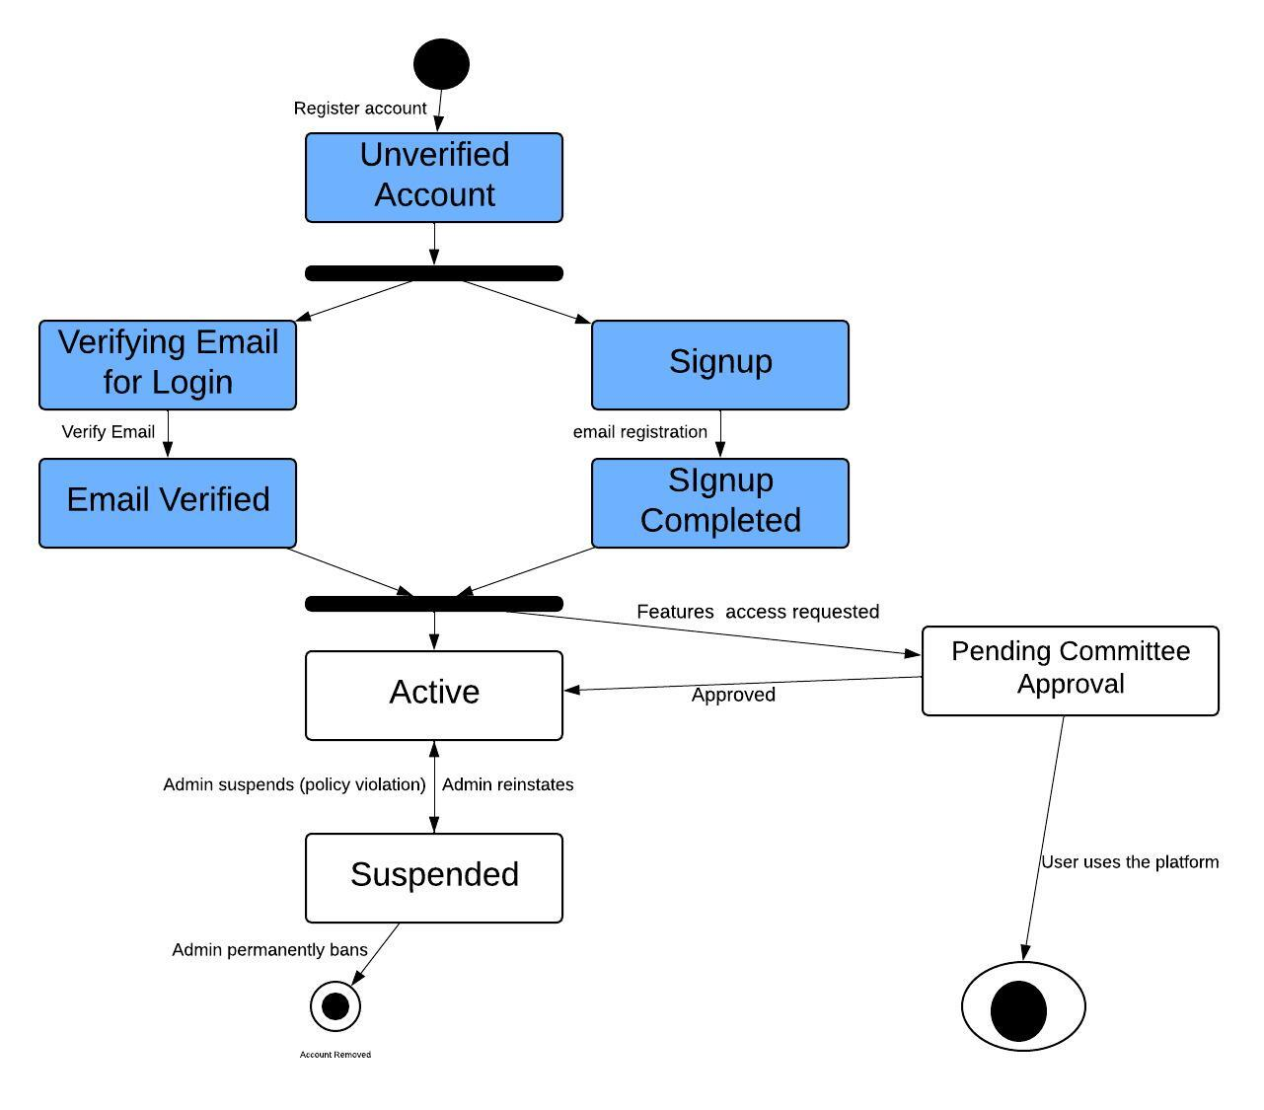

SHREEHARI
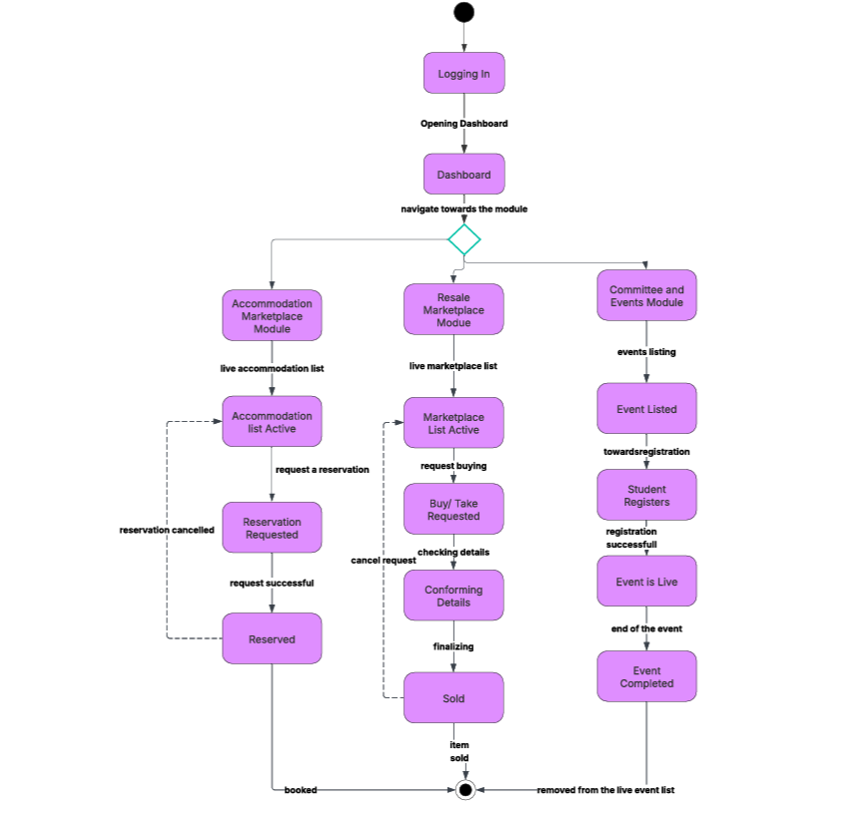

ONKAR

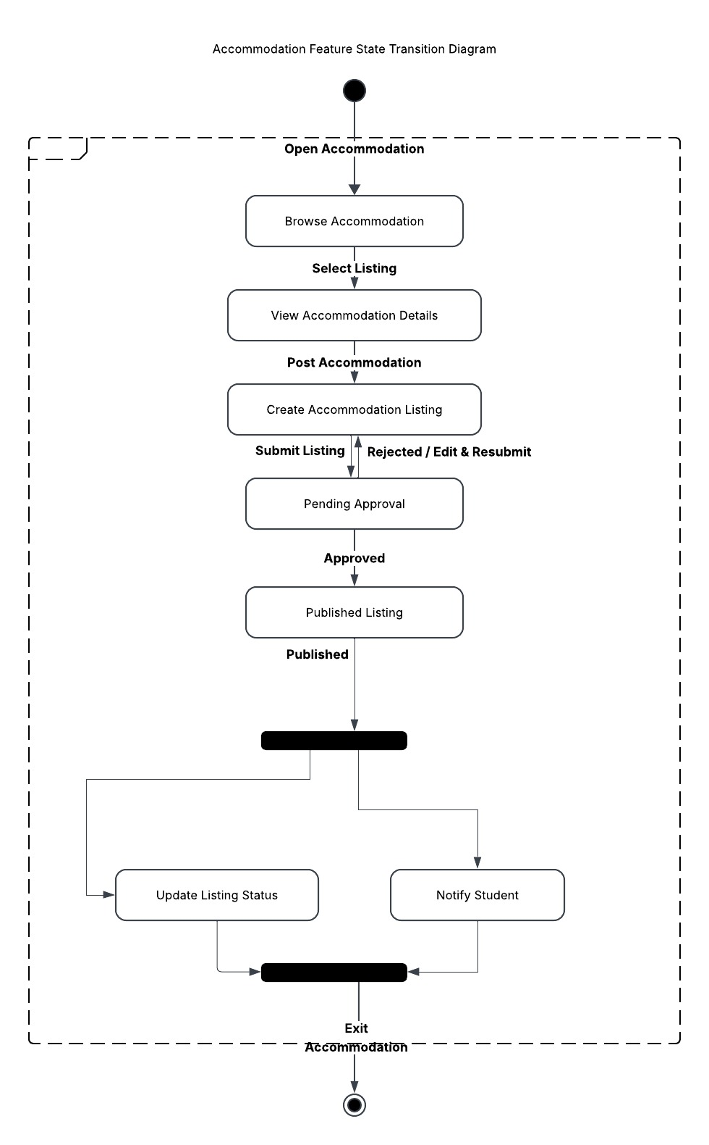

ACTIVITY DIAGRAMS:
Activity Diagrams — Theory
Definition: A UML behavioral diagram that models the flow of control (or data) through a system — the sequence of actions, decisions, and concurrent paths in a process or workflow. Functionally similar to a flowchart, but grounded in UML semantics (based on Petri-net-like token flow) rather than plain procedural logic.
Purpose: Captures what happens in a process — algorithmic logic, business workflows, use-case realizations — independent of which object/class performs each step (unless swimlanes are used to assign responsibility).
Core Notation Elements
Element | Symbol | Meaning
Initial node | Filled black circle | Start of the flow
Activity/Action state | Rounded rectangle | A step or action being performed
Decision node | Diamond | Single input, multiple conditional outputs (guarded by [condition])
Merge node | Diamond | Multiple inputs converge to one output (no condition)
Fork node | Solid bar | Splits one flow into concurrent flows
Join node | Solid bar | Synchronizes concurrent flows back into one
Final node (activity) | Circle with filled dot inside a ring | Ends the entire activity
Flow final | Circle with X | Ends one flow, not the whole activity
Object node | Rectangle | Represents data/object passed between actions
Swimlane/partition | Vertical or horizontal lane | Groups actions by responsible actor, class, or module
Signal send/receive | Concave/convex pentagon | Asynchronous signal exchange
Key Concepts
- Control flow vs object flow: solid arrows show sequencing; dashed arrows (less common) show data/object movement.
- Guards: conditions on outgoing edges from a decision node, written in [brackets]. All guards from one decision should be mutually exclusive and collectively exhaustive.
- Concurrency: fork/join model parallel execution — distinct from a decision, which is exclusive-or branching. Common confusion point: decision = choose one path; fork = execute all paths.
- Swimlanes (partitions): organize actions by who performs them (actor, system module, class) without changing the control-flow semantics — this is what your CampusConnect diagram uses to separate User / Accommodation / Resale / Admin responsibilities.
- Pins: optional parameters on actions representing specific inputs/outputs of that action.
When to Use
- Modeling a use case's internal logic (step-by-step realization)
- Business process modeling
- Algorithms with branching/parallelism
- Workflow across multiple actors or system components (via swimlanes)

AMEYA
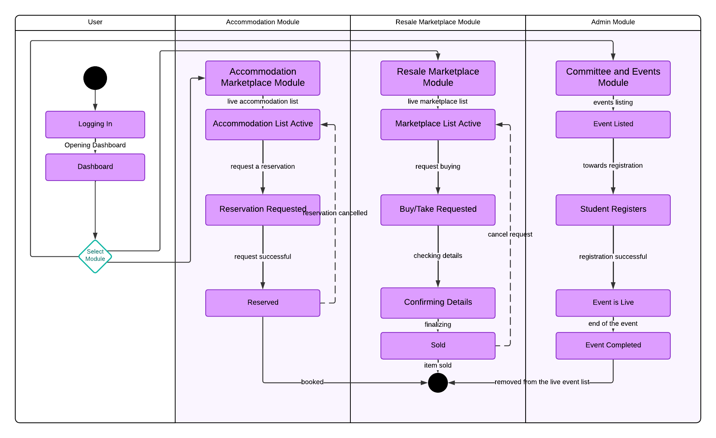

SHREEHARI

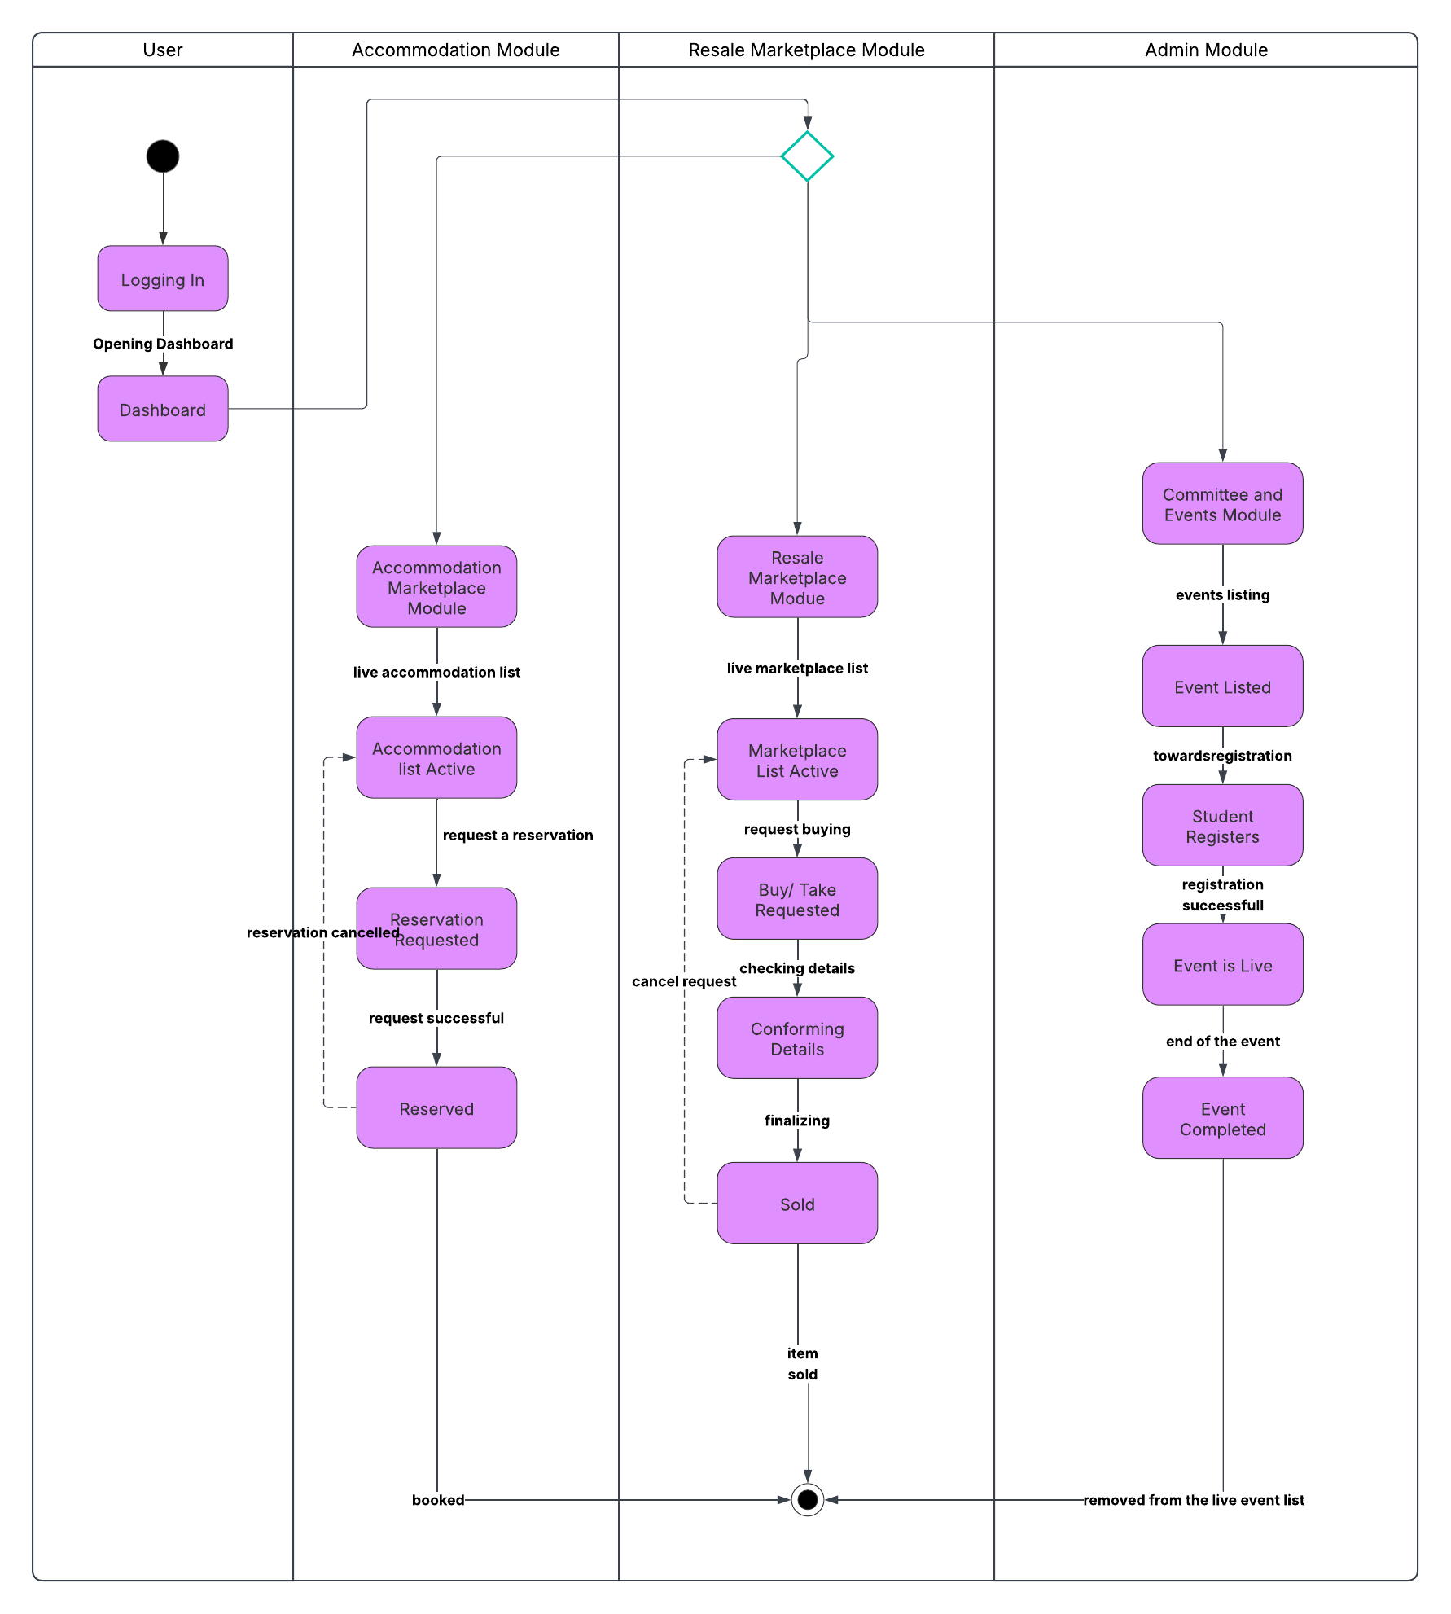

ONKAR
